Entity-Relationship Diagram for The Garage

Lane Dorscher
01/18/2026
CIS309-T302 Data and Information Management (2263-1)
Jack Li

Business Requirements:
The following business narrative is for a small vehicle repair garage.
The garage specializes in individual vehicle repair. The garage needs to track the work they perform for their customers to improve their business. The garage has many customers. Most customers own multiple vehicles and the vehicles are owned by only one customer. For example, customer Jason owns both a truck and a car. The truck and car are only owned by Jason, not a relative of Jason. A vehicle can have multiple repairs. Each repair is specific to a single vehicle. For example, if Jason brings his truck in for a repair in June and again in July, these two repairs are for his truck and not for his second vehicle the car. A mechanic at the garage can work on multiple repairs but a repair is only worked by one mechanic. For example, Mike is a mechanic at the garage. He can make multiple repairs but each repair is only worked by Mike and not another mechanic at the garage.

The garage also needs to know the following:
- The address and name of each customer
- Vehicle make, model, and year
- The date and total cost of each repair
- The name, address, and salary of each mechanic
Identified Entities and Attributes
CUSTOMER
Stores customer contact and billing information
- CUSTOMER_ID (PK) – INT
- CUSTOMER_FIRST_NAME – VARCHAR(30) – NOT NULL
- CUSTOMER_LAST_NAME – VARCHAR(30) – NOT NULL
- CUSTOMER_STREET_ADDRESS – VARCHAR(150) – NOT NULL
- CUSTOMER_CITY – VARCHAR(50) – NOT NULL
- CUSTOMER_STATE – VARCHAR(30) – NOT NULL
- CUSTOMER_POSTAL_CODE – VARCHAR(14) – NOT NULL
- CUSTOMER_PHONE – VARCHAR(12) – NOT NULL
VEHICLE
Stores customers vehicle information
- VEHICLE_ID (PK) - INT
- VEHICLE_MAKE – VARCHAR(30) – NOT NULL
- VEHICLE_MODEL – VARCHAR(30) – NOT NULL
- VEHICLE_YEAR – INT – NOT NULL
- VEHICLE_COLOR – VARCHAR(30) – NULL (optional)
- VEHICLE_VIN – VARCHAR(17) – NOT NULL
- CUSTOMER_ID (FK) – INT – NOT NULL
MECHANIC
Stores information about the mechanic
- MECHANIC_ID (PK)
- MECHANIC_FIRST_NAME – VARCHAR(30) – NOT NULL
- MECHANIC_LAST_NAME – VARCHAR(30) – NOT NULL
- MECHANIC_ADDRESS – VARCHAR(150) – NOT NULL
- MECHANIC_ CITY – VARCHAR(30) – NOT NULL
- MECHANIC_STATE – VARCHAR(30) – NOT NULL
- MECHANIC_POSTAL_CODE – VARCHAR(14) – NOT NULL
- MECHANIC_SALARY – DECIMAL(10,2) – NOT NULL
REPAIR
Represents a repair needed for a customer’s vehicle.
- REPAIR_ID (PK) - INT
- REPAIR_IN_DATE – TIMESTAMP – NOT NULL
- REPAIR_COMPLETED_DATE – TIMESTAMP - NULL
- REPAIR_TOTAL_COST – DECIMAL(10,2) - NULL
- VEHICLE_ID (FK) – INT – NOT NULL
- MECHANIC_ID (FK) – INT – NOT NULL

This is the bare minimum requirement needed to satisfy the business needs. It may be beneficial as a business owner to have setup a “Garage” table with addresses of available garages owned by the business. Having mechanics assigned to each one and data to indicate at which garage the repair was made at. Repair jobs need parts so it may be beneficial to have an inventory of items available or ordered with the cost of the materials used for a specific repair. This would create a clear, traceable receipt of the repairs for the customer.

Proposed Relationships
A CUSTOMER can have many VEHICLES.
A VEHICLE belongs to one and only one CUSTOMER.
A VEHICLE can have many REPAIRS.
A REPAIR is associated with one and only one VEHICLE.
A MECHANIC can perform many REPAIRS.
A REPAIR is performed by one and only one MECHANIC.

Entity Relationship Diagram
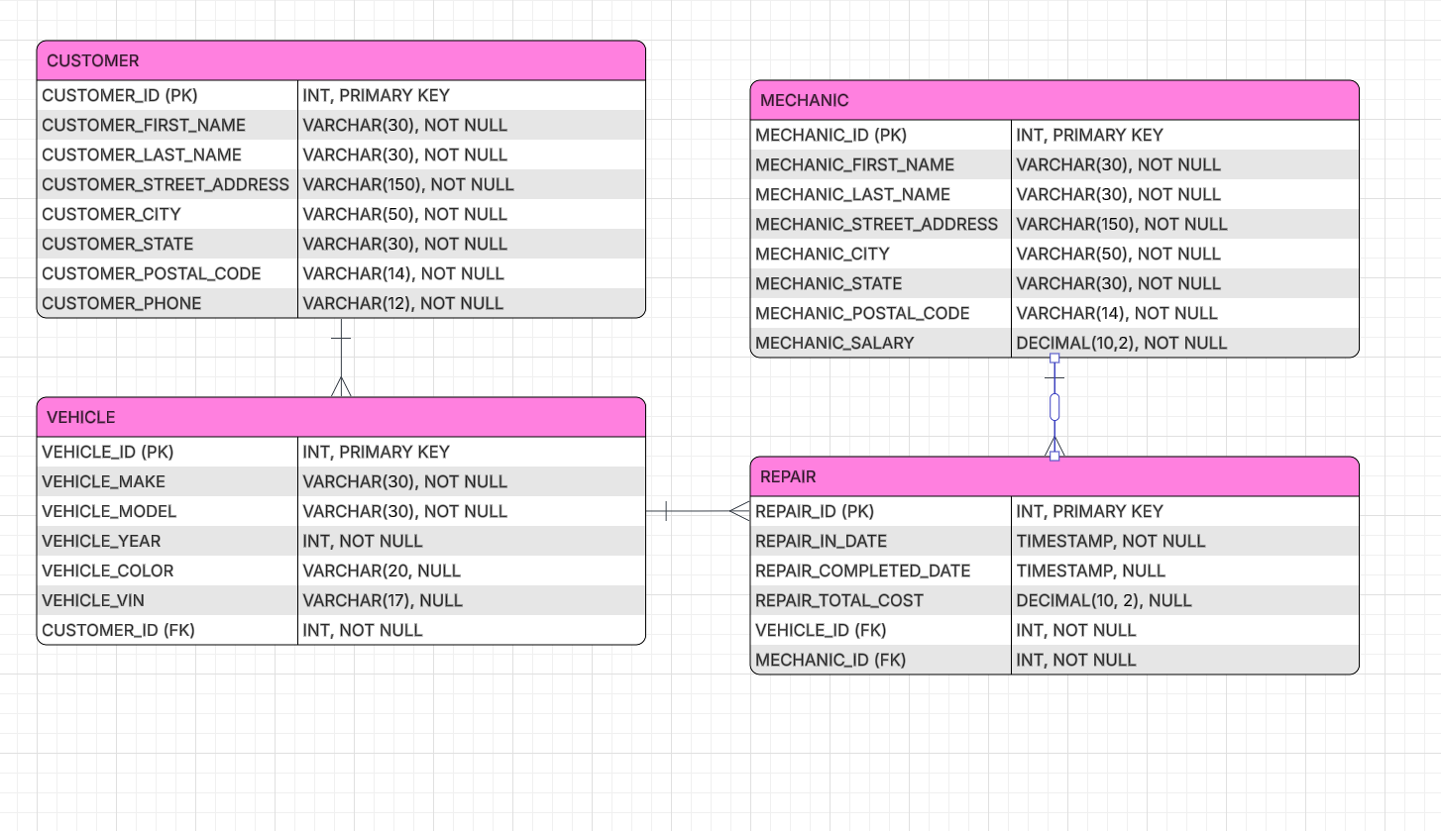
Conclusion
This entity-relationship diagram accurately represents the data requirements of a small vehicle repair garage as described in the business narrative. By identifying the core entities—Customer, Vehicle, Repair, and Mechanic—and defining their attributes, primary keys, and foreign key relationships, the design ensures data integrity and eliminates unnecessary redundancy. The relationships clearly model real-world interactions, such as customers owning multiple vehicles, vehicles undergoing multiple repairs, and mechanics performing multiple repairs while maintaining one-to-one responsibility per repair. While additional entities such as Garage locations or parts inventory could be added in the future to support business growth, the current design satisfies the stated requirements and provides a normalized, scalable foundation for managing the garage’s operational data.

